LAB #11

Simulation of Preemptive Process Scheduling Algorithms



Spring 2023

**CSE-204L Operating Systems Lab**

Submitted by: MUHAMMAD SADEEQ

Registration No.: 21PWCSE2028

Section: C

“On my honor, as a student of the University of Engineering and Technology, I have neither given nor received unauthorized assistance on this academic work”

Submitted to:

Engr. Madiha Sher

(26 May 2023)

Department of Computer systems engineering

University of Engineering and Technology, Peshawar

**TASK 1**

**CODE:**

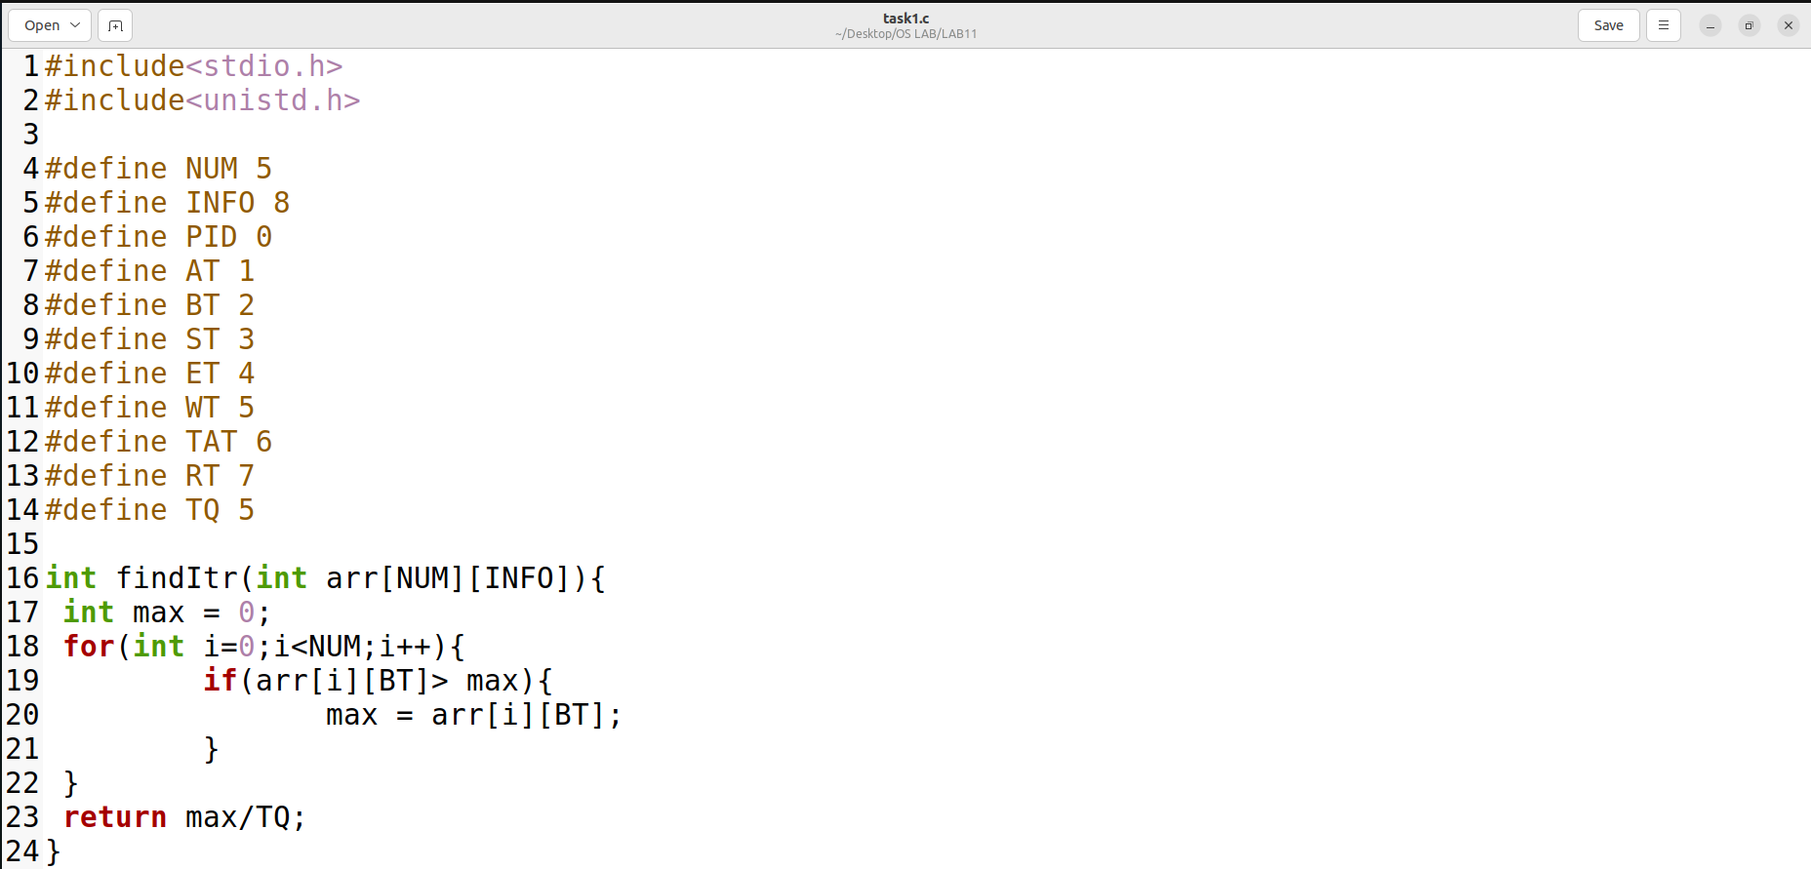

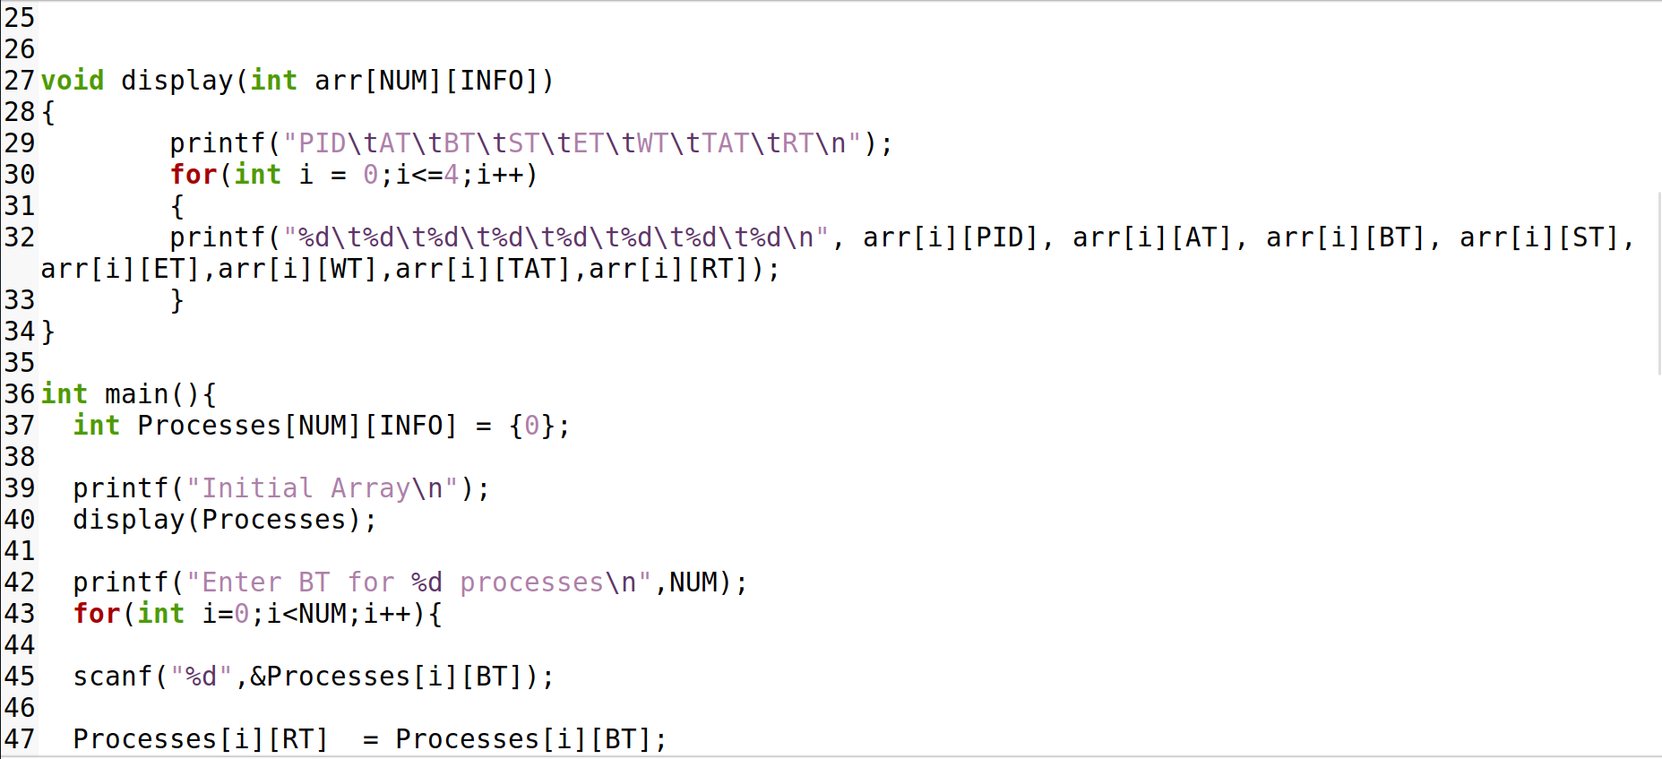

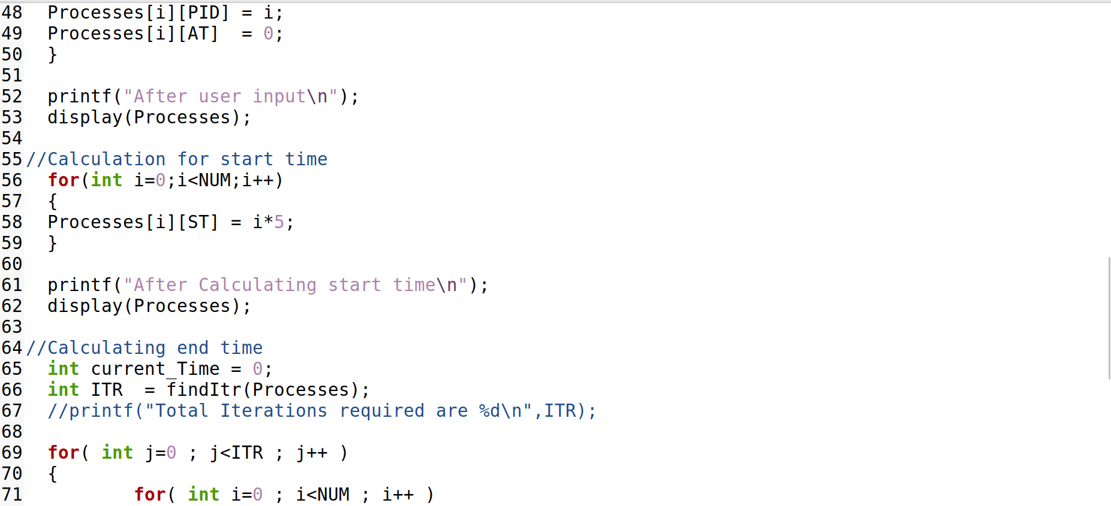

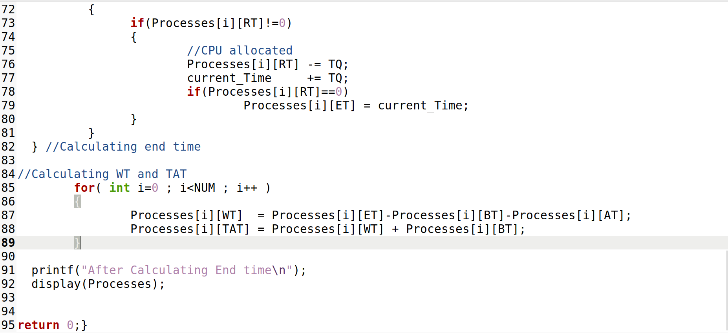

**Output:**

